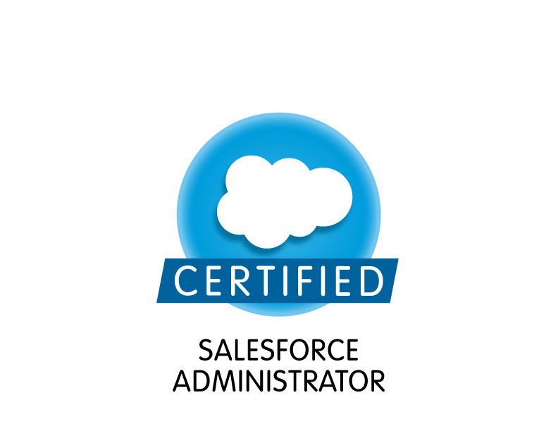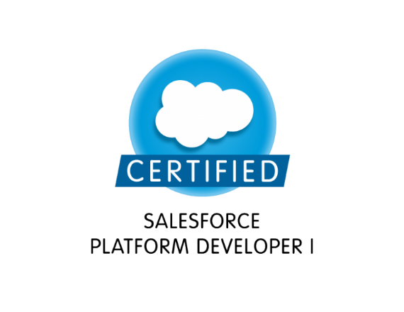

**Nikhil Kumar**

**Phone: (469) 846 8345**

**E-Mail: gnikhilkumarsfdc8@gmail.com**

#### PROFESSIONAL SUMMARY:

* Certified Salesforce Developer with 7+years of experience in the IT industry.
* Participated in all phases of the software development lifecycle including requirements definition, solution design, configuration, code development, testing, deployment and support.
* Expertise with Salesforce Administrative tasks of Creating Users, Profile, Permission Sets, setting up organization role hierarchy, security controls, Remote Site Settings, Email Templates, Connected Apps, and Sites.
* Sound knowledge with Salesforce relationships - Lookup, Master-Detail, Junction Objects, Fields, Dependent Fields, Formula Fields, Validation rules, Page Layouts, Search Layouts, Compact Layouts, Related Lists, Custom Links, Buttons, Tab and List views.
* Proficient with org data sharing by configuring Organization-Wide Defaults (OWD), creating sharing rules using Criteria/Owner based sharing rules on standard and custom objects.
* Extensively worked on declarative programming using workflow rules & approval process and related actions Field updates, Email alert, create Task and Outbound messaging.
* Good experience with Process Builder and consolidated all existing workflow rules into new process flows and created actions like updating child records, auto submission of approval process based on the criteria.
* Build custom report types, Tabular, Summary, Matrix and Joined reports, Analytic Snapshots and Dashboards for different business units and configured the report/dashboard folder visibilities.
* Experience with data loading and extraction using ETL tools as Data Loader, Salesforce.com Import Wizard, Informatica and workbench.
* Hands on experience in writing Apex Classes, Apex Triggers, Developing Visual Force pages.
* Experience in writing batch apex classes, schedule apex, test classes.
* Have good working knowledge in querying salesforce.com database using SOQL&SOSL queries and Governor Limits.
* Experience in deploying various components between different environments using change sets and visual studio
* Good Experience in integrating third party applications with salesforce using REST API.
* Good Experience in CI/CD.
* Highly flexible and accustomed to work in both large and small group settings.
* Excellent Problem solving, Analytical, Communication and interpersonal skills with the ability to communicate confidently with all levels of employers.

#### CERTIFICATIONS:

* Salesforce Certified Administrator (ADMIN 201)
* Salesforce Certified Developer (DEV401)

#### EDUCATION:

* Bachelor of Mechanical Engineering (Osmania University)- 2013
* Master of Computer Engineering Technology (Kent State University) - 2017

#### TECHNICAL SKILLS:

|  |  |
| --- | --- |
| **Salesforce Technologies:** | Apex Language, Apex Classes, Apex Triggers, Apex Scheduler, Workflow and Approvals,SOQL, SOSL, Visual Force (Pages, Components and Controllers), Custom Formulas, Validation Rules, Email Templates, Roles and Profiles. |
| **Salesforce Tools:** | Microsoft Visual studio IDE, Force.com Explorer, Force.com Data Loader, Force.com Excel Connector, Eclipse IDE. |
| **Languages:** | Java,Apex |
| **Web Technologies:** | HTML,CSS, Visual Force |
| **Databases:** | MSSQL Server, SOQL |
| **Operating Systems:** | MS Windows, LINUX, MAC OS-9/10 |
| **Documentation Tools:** | Microsoft Office Suite |
| **Methodologies:** | Agile, Scrum, Waterfall |

#### WORK EXPERIENCE:

**Client: Verizon Connect, San Diego, California June19 – Present Role: Salesforce Developer**

**Responsibilities:**

* Worked closely with business user/analysts and performed detailed analysis of business and technical requirements.
* Developed Apex Classes, Batch jobs, Apex Triggers, Visualforce pages, Scheduled jobs for various functional needs of the application.
* Wrote SOQL and SOSL queries in the apex coding with consideration to Governor Limits for data manipulation needs of the application.
* Created various Custom Objects, Custom Settings, Custom Labels, Custom Metadata types, Validation rules, Record types, Custom Tabs, Workflow rule, Process Builder and approval process.
* Created Page layouts, search layouts to organize fields, custom links, related lists, and other components on a record detail and edit pages.
* Configured S2S to share Account, Opportunity and Opportunity Products records and updated data to another salesforce organization.
* Worked on REST Apienhancements per business requirements.
* Worked on enhancements for Salesforce release updates(Spring ,Summer, Winter).
* Worked on Salesforce CPQ tool, Docusign
* Used tools like GitHub, Atom, data loader, Visual Studio, Jira, techHub

**Client: JP Morgan Chase, Plano, Texas July 18 – May 19Role: Salesforce Developer/Admin**

**Responsibilities:**

* Responsible for gathering the requirements by coordinating with the business analysts, developers and project managers, to better customize, and utilize the full functionality of the Salesforce.com CRM solution.
* Created Custom objects and custom fields in lightning experience.
* Proactively created Apex Triggers and Apex classes and developed and managed complex workflows, approvals, validation rules, assignment rules and system triggers.
* Responsible for writing SOQL & SOSL queries with consideration to Governor Limits for data manipulation needs of the application using platform database objects.
* Created lightning pages for different record types using Lightning App builder.
* Create and Customize Custom Objects, Formula Fields, Cross Object Formulas, Roll up summary fields, validation rules, dependent pick lists, and complex page layouts.
* Created various Profiles, Roles, Page Layouts and configured the Permissions based on the Organization hierarchy requirements.
* DevelopedLightning Components and server-side controllers to meet business requirements.
* Used Salesforce DX toolfor creating scratch orgs and for Pull and Pushing the code to local Repository.
* Implemented pick lists, dependent pick lists, lookups, master detail relationships, validation and formula fields to the custom objects.
* Implemented Data segregation through Record Types and Field level security.
* Audited, uncovered and resolved data integrity issues with legacy systems.
* Completed bulk imports of data using Apex Data Loader.
* Developed different Visual Force Pages to suit to the needs of the application using different Visual force components.
* Used Jenkins, Jira, Bitbucket, Confluence, SharePoint tools for managing the application.

**Client: Keyper Marketing, McKinney, TX Jan 18 - June 18**

**Role: SalesforceDeveloper/Admin**

**Responsibilities:**

* Responsible for gathering the requirements by coordinating with the business analysts, architects and project managers.
* Developed Apex classes, Apex Triggers and Visual Force Pages as per requirements.
* Developed Code to Geo -Track seeker location by using Java script and custom meta data.
* Created Workflows to send email alerts to seekers and connectors as per requirements.
* Created multiple email templates that needs to be sent to connectors and seekers based on different criteria.
* Implemented Process Builder to send SMS along with emails to connectors and seekers by using third party application.
* Integrated third party online missionary organizations with salesforce to pass the seeker information using REST API.
* Developed Apex classes to dynamically validate email and website URL of the connectors for the auto approval process using remote site settings.
* Developed schedule Batch class to remove all the record from remote site settings.
* Writing test class to maintain the 75% code coverage for Apex classes.
* Deployment of the components to the production using Change Sets.

**Client: Standav, Hyderabad, India Aug 14 – Dec 15**

**Role: Salesforce Developer/Admin**

**Responsibilities**:

* Involved in various activities of the project, like information gathering, analyzing the information, documenting the functional and nonfunctional requirements.
* Worked with the user group for requirement gathering throughout the planning and implementation.
* Worked on various SFDC standard and custom objects like Accounts, Contacts, Cases, Contracts, Entitlements, Opportunities, Price books, Products.
* Developed various Custom Objects, Tabs, Components and Visualforce.
* Created custom Dashboards for manager’s home page and gave accessibility to dashboards for authorized people
* Developed Custom Objects, Custom Reports and dashboard on regular basis for the sales performance and lead generation statistics.
* Created various reports (summary reports, matrix reports, pie charts, dashboards) and setup report folders to authenticate users based on their profiles (permissions).
* Customized the Dashboards to the track usage for productivity and performance of business centers and their sales teams.
* Provided the training to the internal business users to use the application and develop their own custom reports.
* Application Support & Knowledge Transfer to App support.

**Client: Minebrat Private Limited, Bengaluru, India July 13 - Aug 14**

**Role: Java Developer**

**Responsibilities**:

* Developed java database using JDBC to access database.
* Designed and developed base classes, framework classes and common re-usable components.
* Involved in UI designs using Java and Swings.
* Used various Java and J2EE APIs including JDBC, XML, JSP, and JavaBeans.
* Involved in re-factoring the existing components to meet the current application requirements.
* Involved in performance tuning, debugging issues in testing and deployment phases.
* Utilized SQL for querying the database.
* Developed customer care related web pages using JSP, JSP Tags and Servlets.
* Created and used lot of business objects related to Customers, Work Orders and Invoices.
* Used JUnit extensively to create unit test cases for the wrapper classes.
* Developed a rating engine and rating report generation logic for the different services provided to the customer.